# Assignment 1:

# Feasibilities, Estimates, Guesstimates, and Assessments: Finding and Using External Secondary Data

Worth 17.5 points

**General Instructions**

Create a single document that has the qualities of a professional research report with an attractive cover page, a letter of transmittal to me, introductory subheadings and brief introductions to the answers to each question. Make good use of graphs, pictures, and figures with along with your explanatory text (always above the tables/graphs).

You don’t need an executive summary or a table of contents. DO NOT retype the questions. DO NOT ramble, but don’t neglect the importance of explaining what you find. DO NOT number your answers and DO NOT start an answer without an intro and brief explanation. This is a formal report to management.

You do not need to start each answer on a new page, but make appropriate use of white space and subheadings to separate sections.

**Details**

Use single-spaced paragraphs but with appropriate space between them (like this sheet of instructions). I’d recommend 11 point type and a 12 point break between paragraphs. Make the margins narrow (probably ½ or ¾ inch) all the way around. Use a professional font (e.g., not comics sans, etc). Paragraphs should be no longer than 3 or 4 sentences before a break. Nearly every paragraph should refer to data that support it (using “as shown below”), and the data should be right after it in a table, graph, or figure. You can snip tables from sources or retype the numbers in an excel table or graph.

**Random Subtitle**

Snipped pics and graphs are necessary to add interest and highlight your findings, but size them appropriately. Every time you use a source, tell me where it came from briefly and the date (Statista, 2021, for example). Then list the sources you used in more detail at the end of each section. They don’t have to be in a particular style.

It will be a (loose) maximum of 14 pages. Pictures and figures should be sized appropriately so text and pictures / figures share a page comfortably. Think Professional Appearance. Write cleanly and crisply.

Remember to make appropriate subheadings for each response and maybe even within a particular response.

In addition to a grade on each answer there is an overall appearance grade. Spelling errors, poor grammar, and dumbass-looking answers are grounds for serious point reductions.

Do NOT use I, you, we, etc. in your answers. Just report.

**First Topic Subtitle (You choose what you feel is an appropriate subtitle)**

Pick a relatively popular outdoor leisure or athletic activity. Use an AI source like ChatGPT and ask it to generate a 200-ish word market analysis that touches on the current state of, potential for, and future of that activity in the United States. Play with it and try and get a feel for the interface. You may have to try 2 or 3 times to get the right question asked. Save it as a Word file. Note the sources it uses, but then go find at least three additional sources that provide supporting insights, data, charts/graphs/figures and maybe even pictures that help flesh out the story. Use it all and prepare an approximate two-page “brief” that summarizes the information from those sources into a really tight guide that will teach a non-expert as much as possible about the size, dynamics, and potential of the market(s) for that activity. Make it interesting and tell a story. The list of sources does not need to be in the two page-ish limit.

Sources to get you started (general):

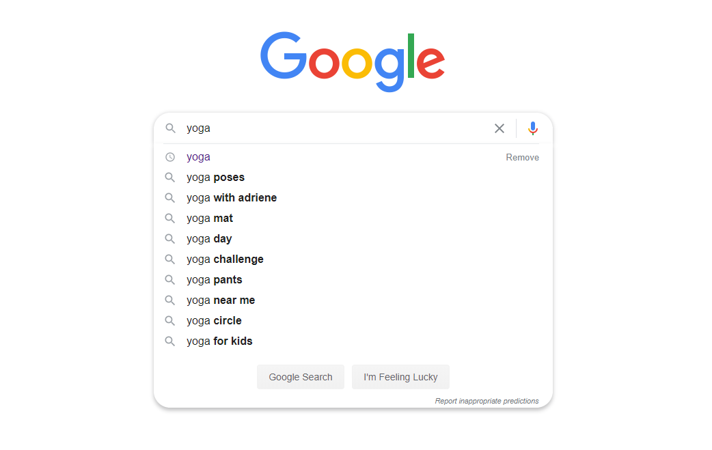

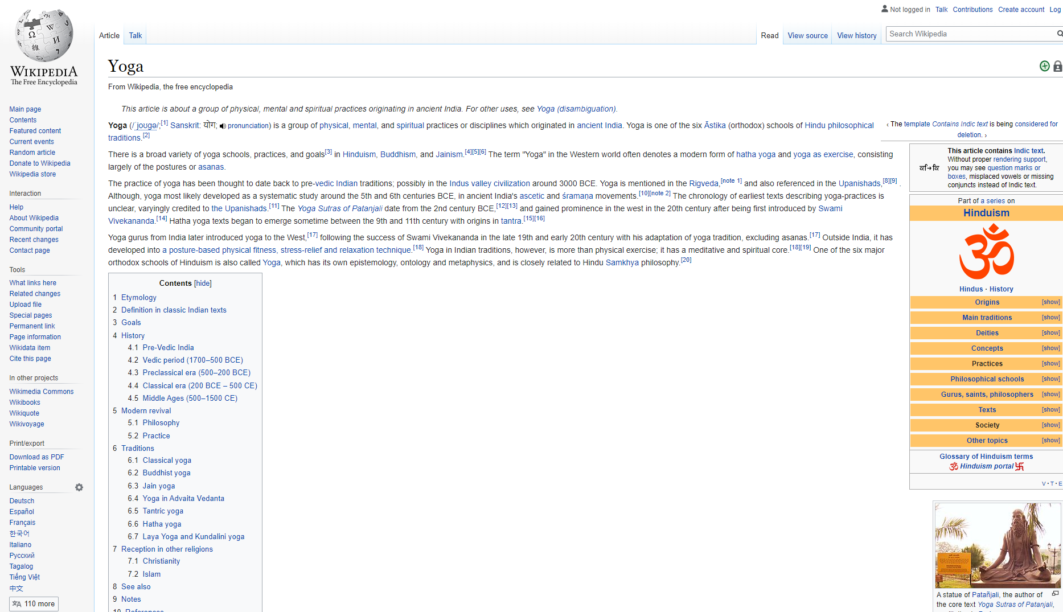

Sources to get you started (in the UA library database):

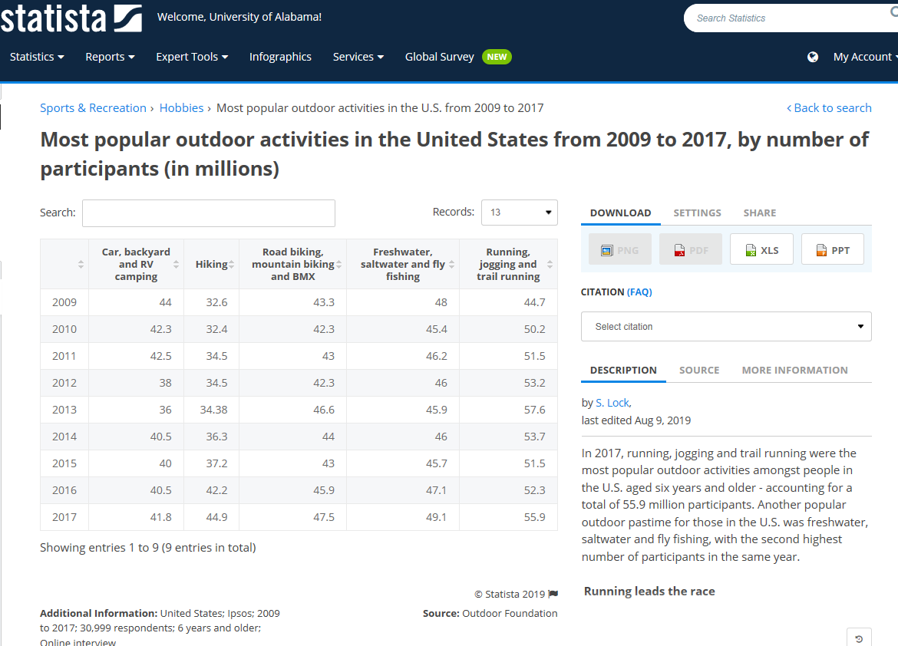

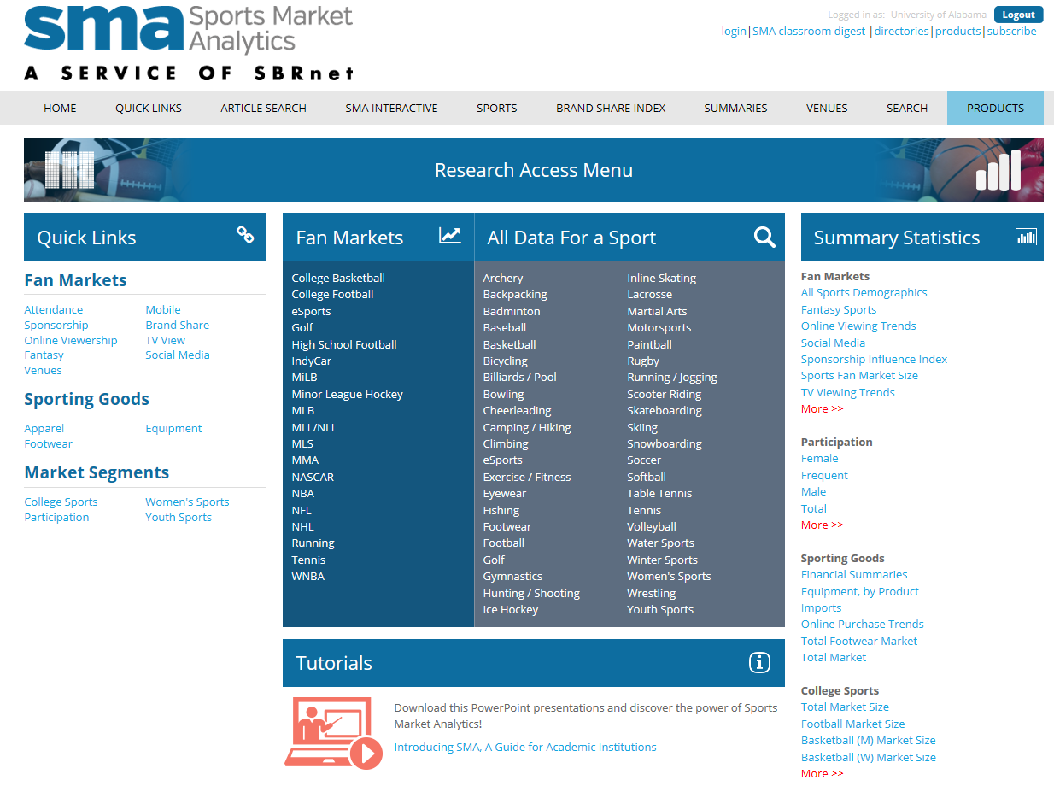

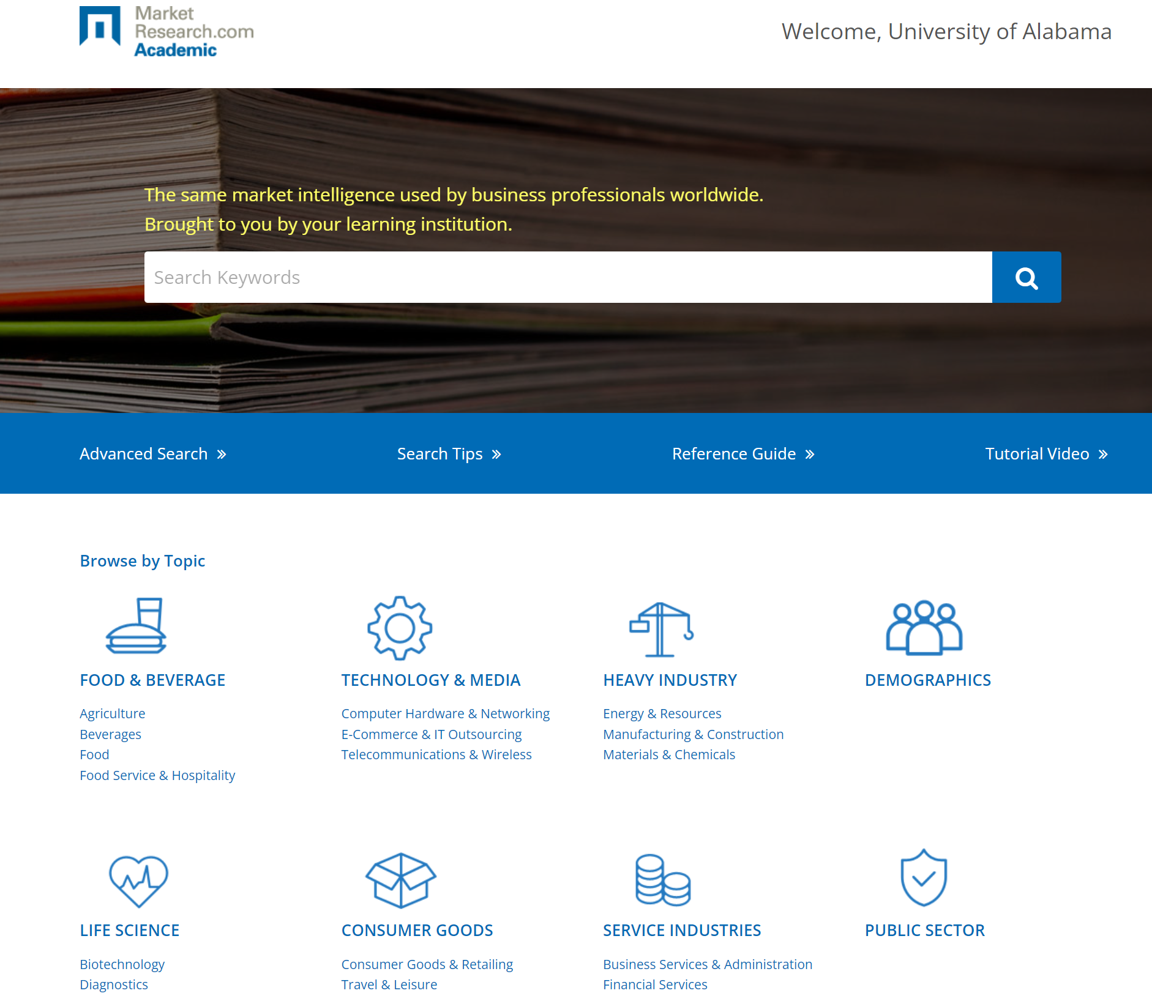

**Second Topic Subtitle**

Pick an indoor leisure or athletic activity that is analyzed in Simmons Insights. Using approximately 10 demographic, segmentation, and lifestyle variables, compare the **high-activity** customer base for that group to the US population as a whole. Make sure you get into the Lifestyle Statements – Attitudes/Opinions-General as at least one source. Export your crosstabs to Excel to work with. Include only the Weighted and Index columns in your tables. Discuss the **Weighted** but emphasize the **index #’s** to help compare your numbers to the US population as a whole. Make up to three tables. Edit the tables before you insert them into the paper. Make sure column titles are easily readable. Do NOT include Horizontal Pct, Vertical Pct, or Sample in your tables. Write a short paragraph describing what is going on in each of your tables and the story you see in the data, referring to the table (“as shown below”) as needed.

Choose recent spending (as shown below).

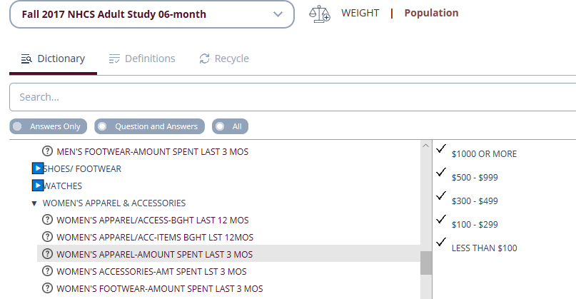

**Third Topic Subtitle**

Do a little research in Statista or Simmons and figure out 5 key demographic variables associated with high movie theater attendance (but make sure you include total population). Then pick a city (probably a pretty big one). Do a little soft research in Google Maps and select two different addresses (or intersections) at least 10 miles apart where there is not currently a movie theater within 3 miles (Google Maps). Make note of the intersections (both roads/Hwy’s). For each, run a single radius 3 mile ring study using the Summary Report tab in EASI Site Analysis in Easidemographics. Keep trying sites until you find two that each have at least 5,000 people within 3 miles. Map the two sites. Then run a Professional Complete Report for each of the two sites. Make a single table that compares the two sites on your 5 key demographics. Discuss the differences between the two sites and choose one (and explain why).

Here is a Google Maps image for Memphis as a starting point example:

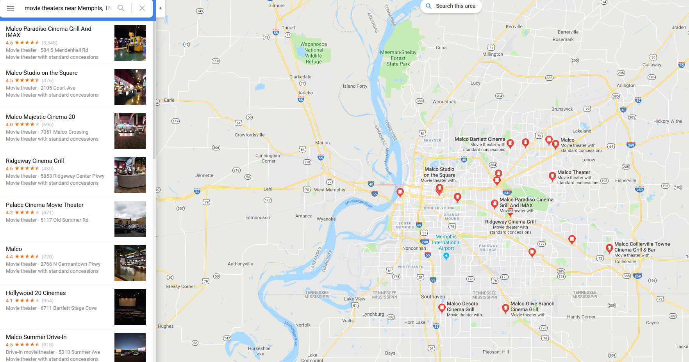

**Fourth Topic Subtitle**

Please make a clean story (and explain a clean and repeatable methodology) which estimates the potential size of the [PICK A U.S. COUNTY] market in dollar revenue per year for portable toilet rentals, day-care center-based day care, and catered Food served on customer or third party premises. Explain your logic, show your work in one or more interesting tables, and summarize your findings (above the table).

**Fifth Topic Subtitle**

Pick a cool college town anywhere in America (not counting Tuscaloosa) where you might like to open a new sports bar that also serves lunch and dinner. Name your bar and describe it briefly (ambiance, target market, etc.).

Use Google Maps to find your campus and make a quick map of the restaurants and bars around it. Snip and crop it.

Pick one existing bar near campus that looks interesting. Find its address from Google Maps. Then use **Reference Solutions** (NAICS 7224 - Drinking Places (Alcoholic Beverages)) and find the details of ownership, revenue, employees, and other key characteristics of the restaurants and bars within a one-mile radius of that one. Which of those existing bars/restaurants look like the coolest to be near (and why)? Where specifically would you try and locate your new sports bar and why?